Project Planning Phase
Project Planning Template (Product Backlog, Sprint Planning, Stories, Story points)

Date | 29 September 2026
Team ID
Project Name | Metro Ticket Generating System Using ServiceNow
Maximum Marks | 5 Marks

Product Backlog, Sprint Schedule, and Estimation (4 Marks)
Use the below template to create product backlog and sprint schedule
Sprint | Functional Requirement (Epic) | User Story Number | User Story / Task | Story Points | Priority | Team Members
Sprint-1 | Application & Data Setup | USN-1 | As an administrator, I can create a scoped application in ServiceNow to organize all components of the Metro Ticket Generating System. | 2 | High | Manasa Pothina
Sprint-1 |  | USN-2 | As an administrator, I can create the Metro Station table and add the station records Central, City Square and Airport. | 2 | High | Manasa Pothina
Sprint-1 |  | USN-3 | As an administrator, I can create the Metro Fare Rule table and configure the base fare (₹10) and the additional fare (₹5 per station). | 3 | High | Manasa Pothina
Sprint-1 |  | USN-4 | As an administrator, I can create the Metro Tickets Booking table with fields for ticket number, source station, destination station, passenger count, total fare, booking status and QR Code Data. | 5 | High | Manasa Pothina
Sprint-2 | Fare Calculation & Ticket ID | USN-5 | As a user, I can select the source and destination stations from the station list when creating a booking. | 2 | High | Manasa Pothina
Sprint-2 |  | USN-6 | As a user, I can get the total fare calculated automatically by a Business Rule using the configured fare rule, instead of entering it manually. | 5 | High | Manasa Pothina
Sprint-2 |  | USN-7 | As a user, I can receive a unique ticket number for every booking so that each ticket can be identified and tracked. | 3 | High | Manasa Pothina
Sprint-2 |  | USN-8 | As a user, I can enter the number of passengers so that it is stored with the booking and the fare follows the implemented passenger-count logic. | 2 | Medium | Manasa Pothina
Sprint-3 | Booking Automation | USN-9 | As a user, I can have my booking status set to Confirmed automatically by the Flow Designer flow “Metro Booking Confirmation” when the booking is created. | 5 | High | Manasa Pothina
Sprint-3 |  | USN-10 | As an administrator, I can activate the flow and test it with a new booking to confirm that the status updates correctly. | 2 | High | Manasa Pothina
Sprint-3 | Validation & Records | USN-11 | As an administrator, I can rely on validation that prevents incomplete bookings (for example, a missing source, destination or passenger count). | 3 | Medium | Manasa Pothina
Sprint-3 |  | USN-12 | As ticketing staff, I can view booking records showing the ticket number, journey, total fare and status in one place. | 2 | Medium | Manasa Pothina
Sprint-4 | Testing & Documentation | USN-13 | As a tester, I can run test cases TC01–TC07 (fare calculation, ticket number, booking status, station data, validation, multiple passengers, repeated bookings) and record the actual results. | 5 | High | Manasa Pothina
Sprint-4 |  | USN-14 | As a project team member, I can capture screenshots as evidence and prepare the final project report. | 3 | Medium | Manasa Pothina
Backlog | Digital Ticket (Future) | USN-15 | As a passenger, I can receive a QR-code digital ticket that can be verified at entry (future enhancement). | 5 | Low | Manasa Pothina
Backlog | Notifications (Future) | USN-16 | As a passenger, I can receive an email notification with my ticket details and booking confirmation (future enhancement). | 3 | Low | Manasa Pothina
Backlog | Passenger Self-Service (Future) | USN-17 | As a passenger, I can book a ticket through a self-service interface by choosing stations and the number of passengers (future enhancement). | 5 | Low | Manasa Pothina
Story point scale (Fibonacci): 1 = very easy, 2 = normal, 3 = moderate, 5 = difficult. The project was carried out individually. Sprint-1 to Sprint-4 (USN-1 to USN-14) are completed; USN-15 to USN-17 are future enhancements that are not part of the delivered scope and are not counted in the sprint totals or velocity.

Project Tracker, Velocity & Burndown Chart: (4 Marks)
Sprint | Total Story Points | Duration | Sprint Start Date | Sprint End Date (Planned) | Story Points Completed (as on Planned End Date) | Sprint Release Date (Actual)
Sprint-1 | 12 | 6 Days | 29 Sep 2026 | 04 Oct 2026 | 12 | 04 Oct 2026
Sprint-2 | 12 | 6 Days | 05 Oct 2026 | 10 Oct 2026 | 12 | 10 Oct 2026
Sprint-3 | 12 | 6 Days | 11 Oct 2026 | 16 Oct 2026 | 12 | 16 Oct 2026
Sprint-4 | 8 | 6 Days | 17 Oct 2026 | 22 Oct 2026 | 8 | 22 Oct 2026
Total | 44 | 24 Days | 29 Sep 2026 | 22 Oct 2026 | 44 | 22 Oct 2026

Velocity:
Sprint duration = 6 days. Total story points completed = 12 + 12 + 12 + 8 = 44 over 4 sprints. Velocity = Total story points ÷ Number of sprints = 44 ÷ 4 = 11 story points per sprint. The team’s average velocity (AV) per iteration unit (story points per day) is calculated as follows:
AV = Velocity ÷ Sprint Duration = 11 ÷ 6 ≈ 1.83 story points per day
Burndown Chart:
A burn down chart is a graphical representation of work left to do versus time. It is often used in agile software development methodologies such as Scrum. However, burn down charts can be applied to any project containing measurable progress over time.
https://www.visual-paradigm.com/scrum/scrum-burndown-chart/
https://www.atlassian.com/agile/tutorials/burndown-charts
Burndown for this project: All 44 planned story points were completed across the four sprints, finishing on 22 October 2026, before the 23 October 2026 deadline. The remaining work at the end of each sprint was 32, 20, 8 and 0, so the actual burndown followed the planned (ideal) burndown.
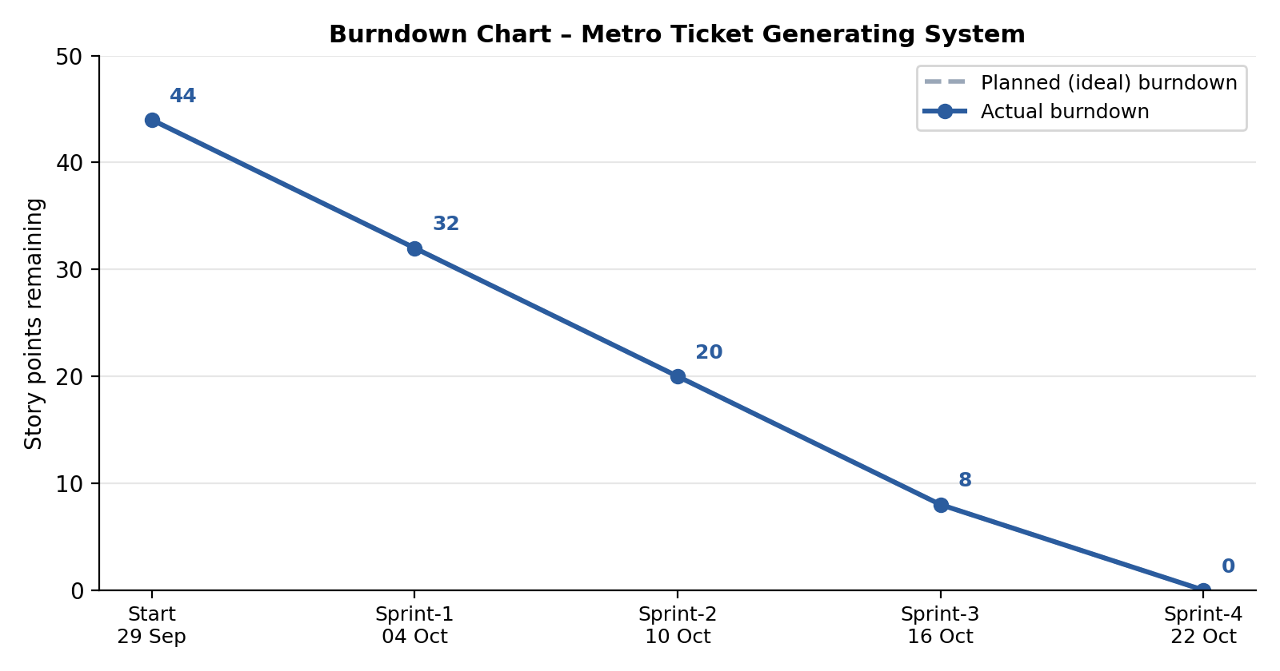
Figure 1: Planned vs actual burndown chart, Sprint-1 to Sprint-4
Reference:
https://www.atlassian.com/agile/project-management
https://www.atlassian.com/agile/tutorials/how-to-do-scrum-with-jira-software
https://www.atlassian.com/agile/tutorials/epics
https://www.atlassian.com/agile/tutorials/sprints
https://www.atlassian.com/agile/project-management/estimation
https://www.atlassian.com/agile/tutorials/burndown-charts

